TITLE: If Palestinians Are a People, Does That Necessitate a State?

SUBTITLE: We can understand their aspirations for self-determination. In this, they are like so many other peoples.
In a recent article, I argued that Yasser Arafat's Cairo birthplace does not disqualify him as a Palestinian.
Many readers agreed that the “Arafat-was-born-in-Cairo-so-there-is-no-such-thing-as-Palestinians” argument is weak. But several immediately moved to a different question:
"Fine. Suppose we accept that Palestinians are a people. Does that mean they are entitled to a state?"
At first glance, the answer seems obvious. Many people assume that once the existence of a people is established, statehood naturally follows. Perhaps, for some, this assumption lies behind the reluctance to accept Arafat being Palestinian and the Palestinian Arabs being a national group.
For this reason, much of the public debate gets stuck on genealogy — birthplace, surnames, or claims of ‘indigeneity’ — as if national identity were a matter of bloodlines. But modern peoples, including Jews (whose surnames often shifted under pressure), Americans (whose surnames overwhelmingly come from elsewhere), Argentinians (whose population is largely descended from Italian and Spanish immigrants), and Turks (whose surnames were legally assigned only in 1934), show that identity is not determined by ancestral purity.
Reader Zev Spitz offered a helpful way of naming something familiar but often left implicit: There are wider identities, such as Arab or Muslim, and narrower ones, such as clan or tribe. Extending that vocabulary, we can also speak of “middle identities:” the modern national identities that sit between broad civilizational categories and intimate kinship groups. Jordanians can be Arab, Muslim, and Jordanian at the same time. Egyptians can be Arab, Muslim, and Egyptian. So why should Palestinians be unable to be both Arab and Palestinian?
Even granting Palestinian peoplehood, statehood is a separate issue.
While peoplehood and statehood are related, they are not the same thing.
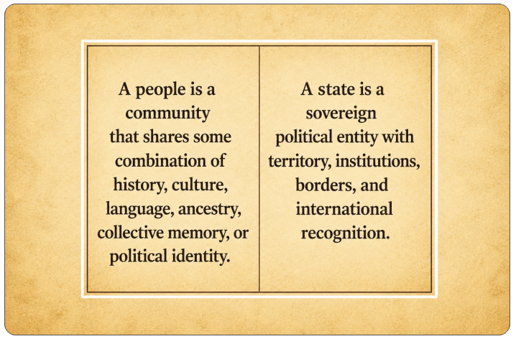
Some peoples achieve states; others do not; and the reasons vary. The table below illustrates this diversity rather than implying direct analogy.

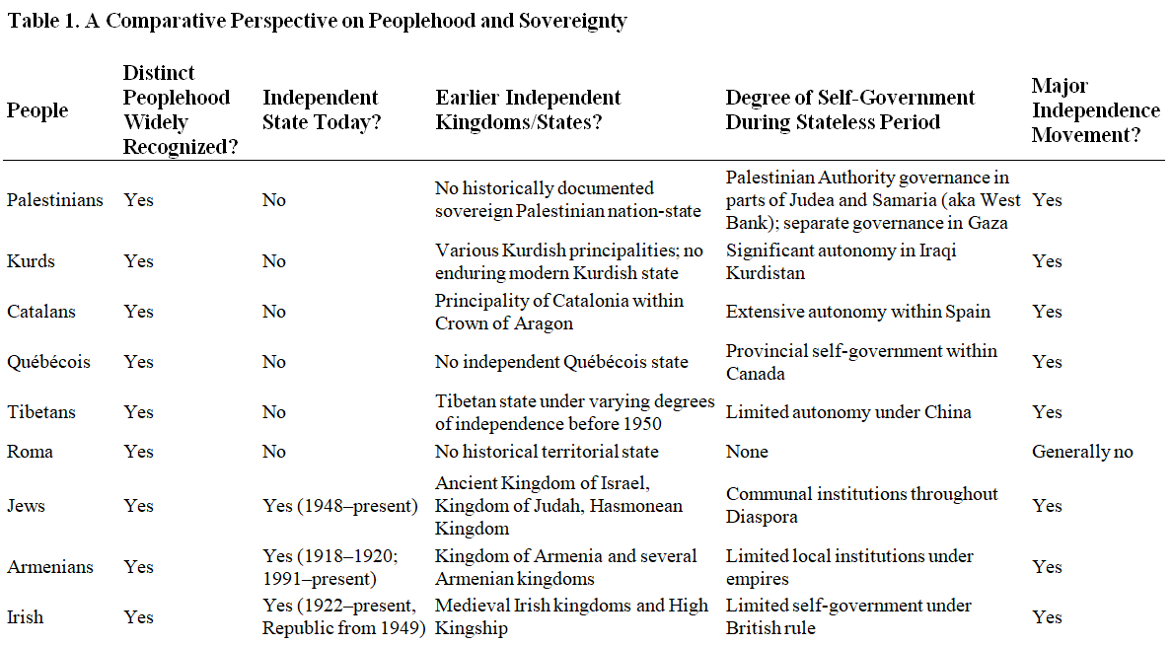

Nor are these the only examples. Scots, Welsh, Corsicans, Baloch, Chechens, Tamils, Sikhs, Kashmiris and many others have maintained distinct identities without achieving sovereign statehood.
These cases are not direct analogies to the Palestinian situation; they simply illustrate that peoplehood and statehood do not always align. In other words, statehood, historically, has depended on a mix of political, territorial, and international factors and not merely the existence of a distinct people.
The existence of a people may explain why the aspirations for self-determination emerge; it determines neither if, nor how, those aspirations must be realised.

Why This Matters
The Israeli-Palestinian debate often collapses multiple questions into one.
One side argues:
"There is no Palestinian people; therefore there is no need to talk about a Palestinian state"
The other argues:
"There is a Palestinian people, therefore there must be a Palestinian state."
But if we want to have a serious discussion about the future, it helps to keep the issues separate. We can acknowledge that today, for whatever reason and by whatever process of evolution, there are millions of people who identify as Palestinians. That does not lock into inevitability a sovereign state.

